

**Back-End Development (BED)**

Level 2.1

Academic Year 2024-25 April Semester

## SCHOOL OF INFOCOMM TECHNOLOGY

Diploma in Information Technology

**ASSIGNMENT**

Duration: **Week 4 to Week 15 (06 May – 28 Jul 2024)**

Weightage:55%

Individual/Team/Both: Both

Deadlines: Checkpoint 1 (Preliminary Submission):

**2359hr Sunday 26 May 2024 (Week 6)**

|  |  |  |
| --- | --- | --- |
| **Class Group** | : | IT07 |
| **Tutor** | : | Henry Neo |
| **Team ID** | : | 6 |

**Please fill in your Student Number and Name as appeared on your student card:**

|  |  |  |  |
| --- | --- | --- | --- |
| **Theme:** | **Social Impact — Tuition Centre System** | | |
| **Student No.** | **Student Name** | **Functions In-Charged** | **Overall Grade** |
| S10260527 | Heng Wei Jian Marvin | Document Formatting & Compilation, Master Pages, Package 1, Package 2 |  |
| S10257399 | Lim Zishun Jovan | Site Map, Package 3, Package 4 |  |
| S10257164 | Lucas Toh Zhou Xuanzhi | Package 5, Package 6 |  |

**Penalty for late submission:**

10% of the marks will be deducted every day after the deadline.

**NO** submission for Checkpoint 1 will be accepted after 2nd Jun 2024, 11:59 PM.

**CONTENT PAGE**

1. Site Map of The Brain Jam System (Jovan Lim, S10257399)4
2. Storyboards of The Brain Jam System5

2.1 Master Pages (Marvin Heng, S10260527)5

2.1.1 Master Page — Homepage5

2.1.2 Master Page — Login Page6

2.2 Package 1 — Student User (Marvin Heng, S10260527)6

2.2.1 Student Classes View6

2.2.2 Student Class View7

2.2.3 Student Assignments View7

2.2.4 Edit Student Assignment Status8

2.2.5 Student Tests View9

2.3 Package 2 — Admin User (Marvin Heng, S10260527)9

2.3.1 Admin Login Page9

2.3.2 Admin Classes View10

2.3.3 Admin Class View10

2.3.4 Deleting Class11

2.3.5 Editing Class Info12

2.3.6 Adding Student to Class12

2.3.7 Adding Teacher to Class13

2.3.8 Creating a New Class14

2.3.9 Creating a New Teacher Account14

2.4 Package 3 — User Sign Up (Student, Parent) (Jovan Lim, S10257399)15

2.4.1 Create New Account Page15

2.4.2 Create New Student Account15

2.4.3 Create New Parent Account16

2.5 Package 4 — Teacher User (Jovan Lim, S10257399)16

2.5.1 Teacher Classes View16

2.5.2 Teacher Class View17

2.5.3 Teacher Assignments View17

2.5.4 Teacher Tests View18

2.5.5 Teacher People View18

2.5.6 Inviting Students19

2.5.7 Editing Student’s Progress19

2.5.8 Parent Teacher Feedback View20

2.6 Package 5 — Parent User (Lucas Toh, S10257164)21

2.6.1 Parent Teacher Feedback Input21

2.6.2 Payment for Child’s Tuition21

2.6.3 Learning Progress Overview22

2.6.4 Parent Class View23

2.6.5 Class Syllabus View23

2.7 Package 6 — User Login (Student, Parent, Teacher) (Lucas Toh, S10257164)24

2.7.1 Student Login Page24

2.7.2 Parent Login Page24

2.7.3 Teacher Login Page25

3. Credits26

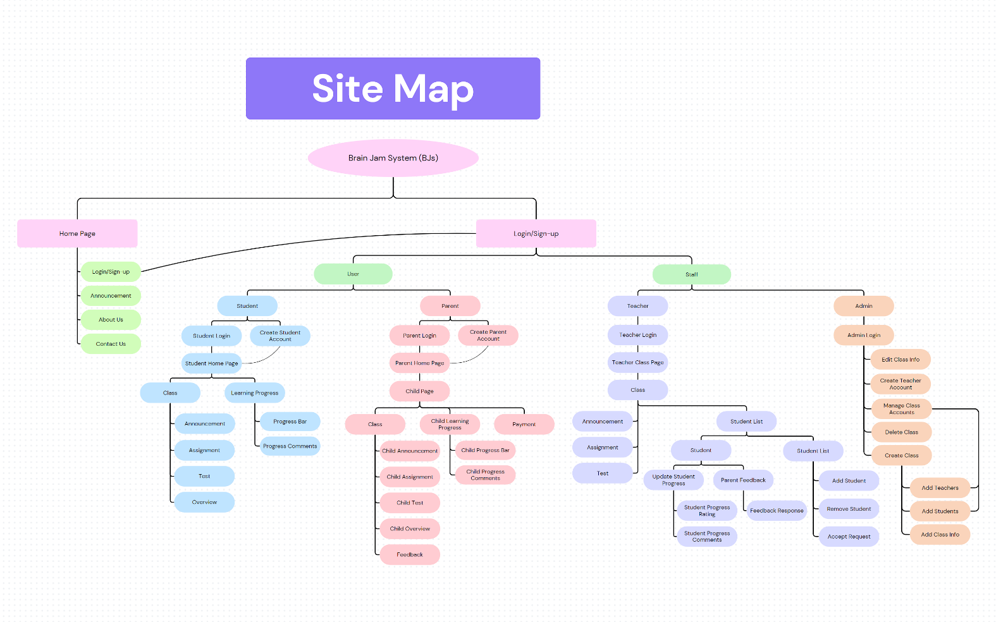**SITE MAP (1)**

**STORYBOARDS OF  
THE BRAIN JAM SYSTEM (2)**

**2.1 Master Pages (Marvin Heng, S10260527)**

**2.1.1 Master Page — Homepage**

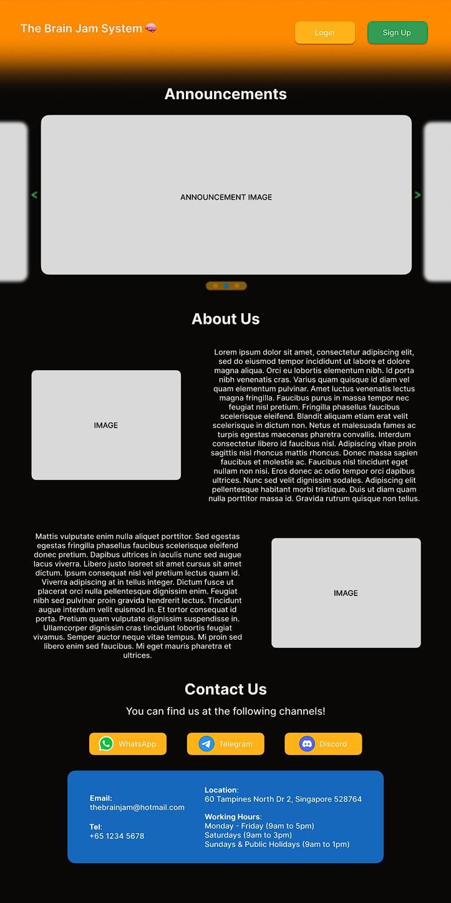

On this page, users get to view public announcements by the tuition centre, as well as an About Us section for those interested to know more. Below that, there is a Contact Us section with buttons that link to the tuition centre’s socials, as well as their email, telephone number, address, and working hours. At the top in the header, users can click on either the Login or Sign Up button, which directs them to the respective page to continue.

**2.1.2 Master Page — Login Page**

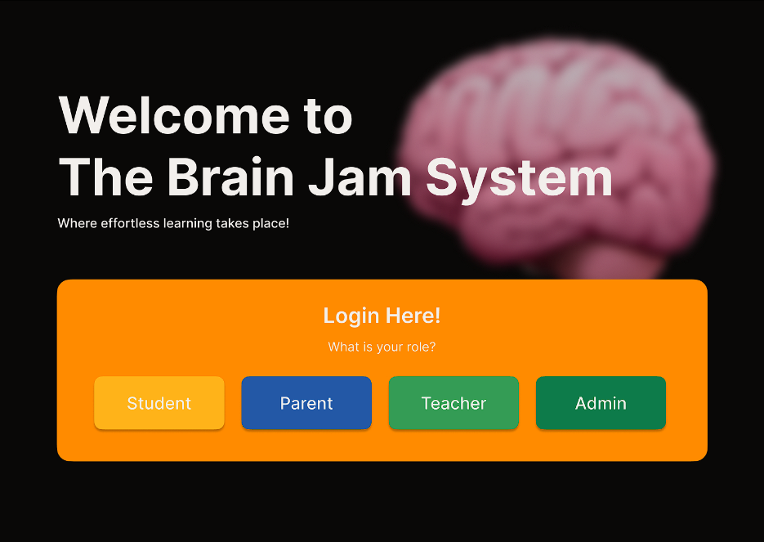

Users at this page select their role in the tuition centre, which will then direct them to the respective login page for each type of user.

**2.2 Package 1 — Student User (Marvin Heng, S10260527)**

**2.2.1 Student Classes View**

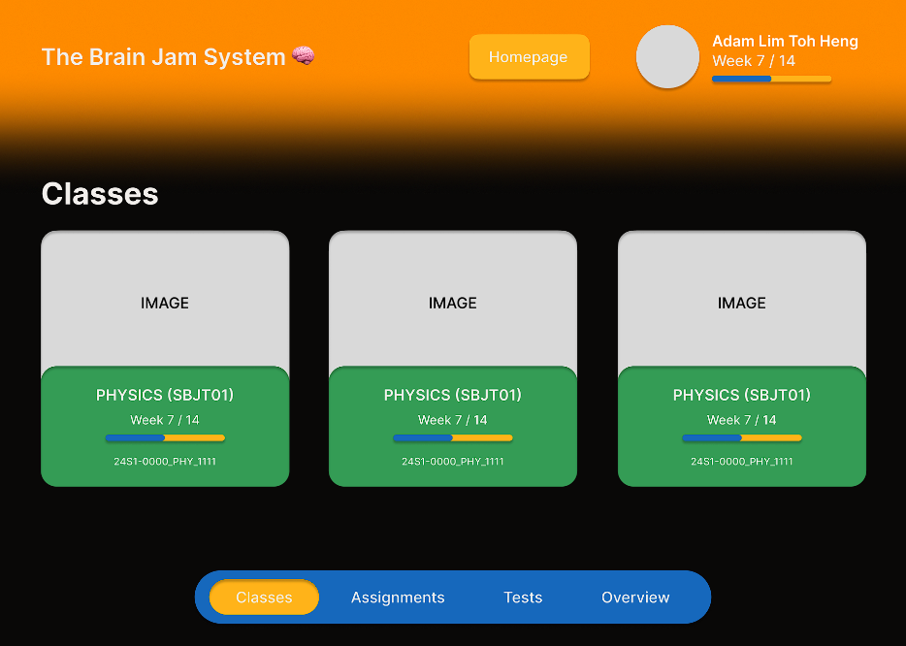

Student Users get to view their classes on this page. In the header, there is a Homepage button that directs them back to **2.1.1 Master Page — Homepage**. Beside that, there is a profile picture and their name, along with their overall progress of all their subjects combined. Under the Classes section, there is a box for each class they are participating in, which contains the class banner, class name, their progress for that specific class, and the class code. Clicking on any of the classes will direct them to the respective class page. The navigation bar at the bottom directs the user to the respective pages.

**2.2.2 Student Class View**

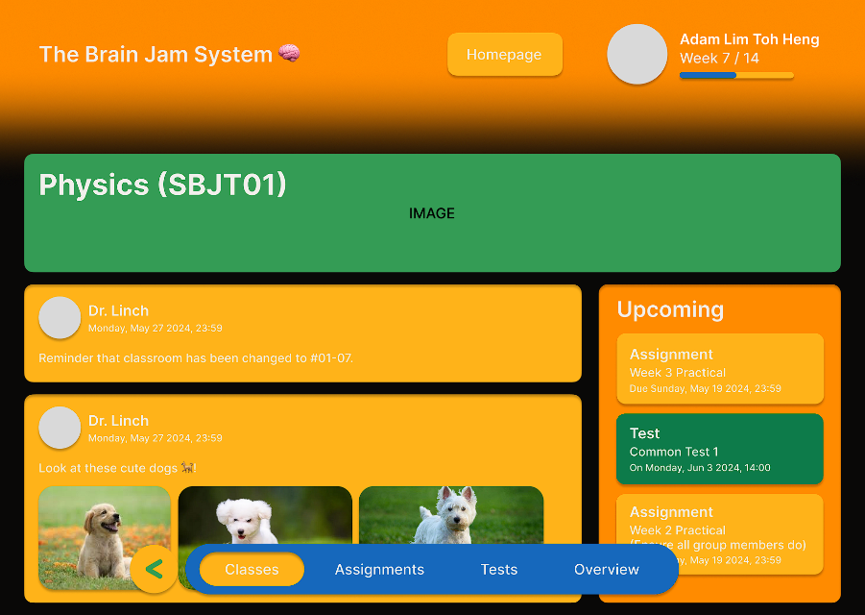

At the start of the page, there is the class name, along with its class banner. On the left, there are class announcements posted by the teacher to the students, and on the right, an overview of upcoming stuff for that class (e.g. assignments, tests, etc.). The back button beside the navigation bar directs the user to **2.2.1 Student Classes View** page.

**2.2.3 Student Assignments View**

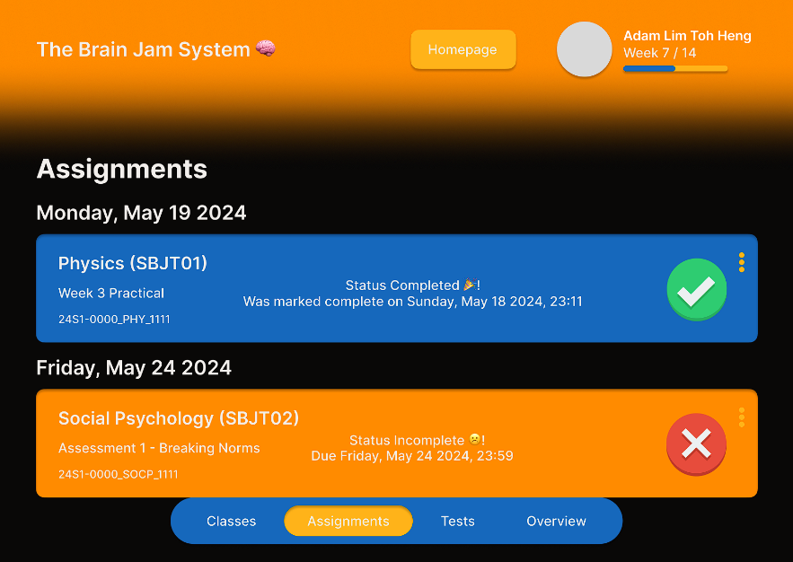

Student Users on this page get to view upcoming assignments with their details (e.g. class name, assignment name, assignment status, class code), sorted by the due date. For completed assignments, the date it was marked complete is shown, while incomplete assignments will have their due date shown.

**2.2.4 Edit Student Assignment Status**

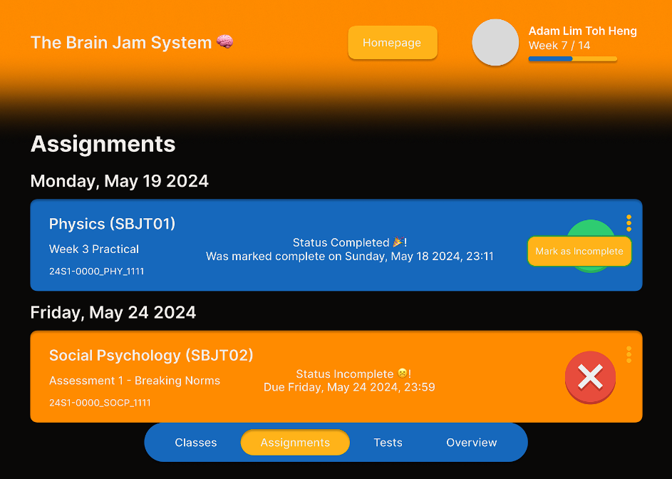

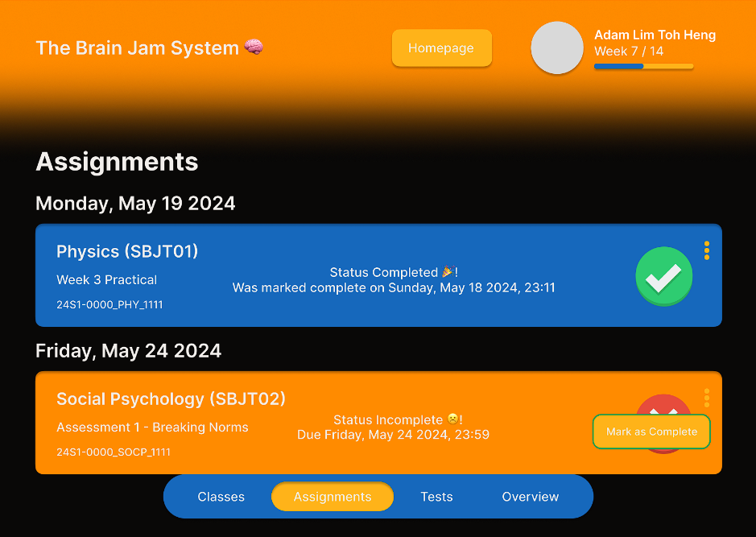

By clicking on the 3 menu dots of the assignment, Student Users can change the assignment status with Mark as Incomplete for completed assignments, and Mark as Complete for incomplete assignments. This view is just for students to keep track of their assignments. Submission of assignments are done in class and will be recorded down by the teacher present.

**2.2.5 Student Tests View**

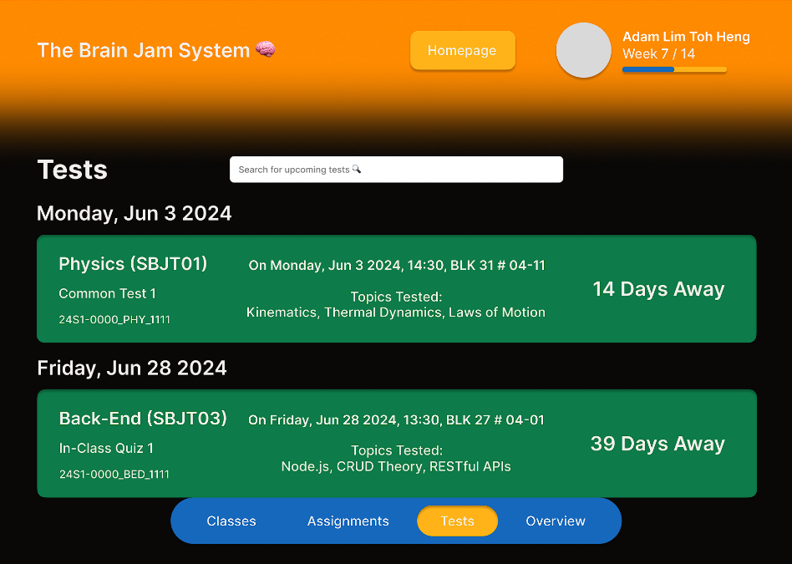

Students can view upcoming tests, sorted by test date. Each box will show test details (e.g. class name, test name, class code, test date and location, topics tested) and number of days away from the test. At the top, there is also a search box for students to search for a specific test by keyword.

**2.3 Package 2 — Admin User (Marvin Heng, S10260527)**

**2.3.1 Admin Login Page**

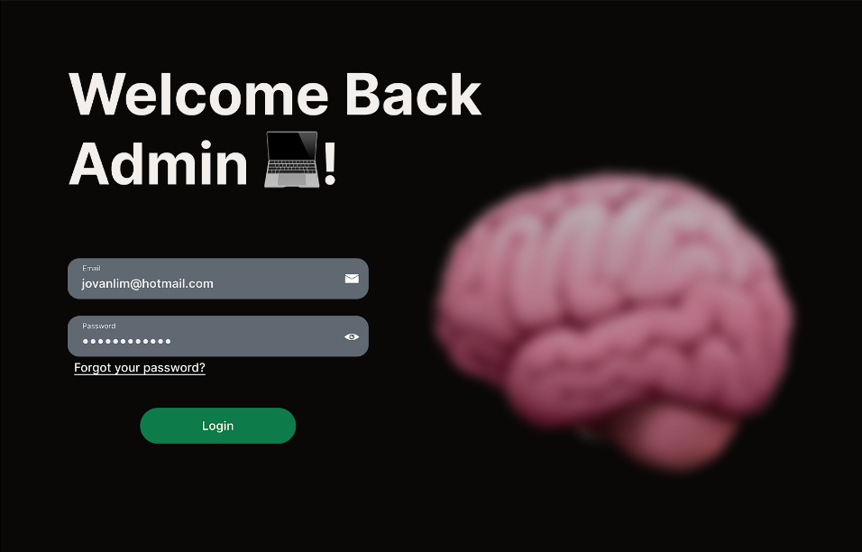

This is the login page for Admin Users. They have to key in their email address and their password to click Login and access admin functions. If they key in the correct credentials, they will be redirected to the admin homepage. If incorrect credentials are entered, the system will show an error message, “Invalid credentials. Please try again!”.

**2.3.2 Admin Classes View**

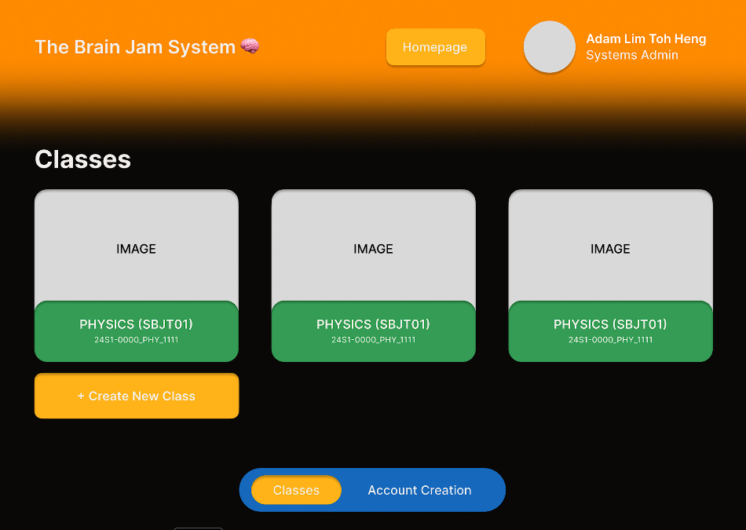

Once logged in, the Admin User is directed to this page. In the header, the button Homepage directs the user to **2.1.1 Master Page — Homepage**, and to the side, the admin’s profile picture, name, and admin level. Under the classes section, each box for the classes have the class banner, class name, and class code. Below that section, there is a + Create New Class button that directs the Admin User to the class creation page. The navigation bar at the bottom directs the user to the respective pages.

**2.3.3 Admin Class View**

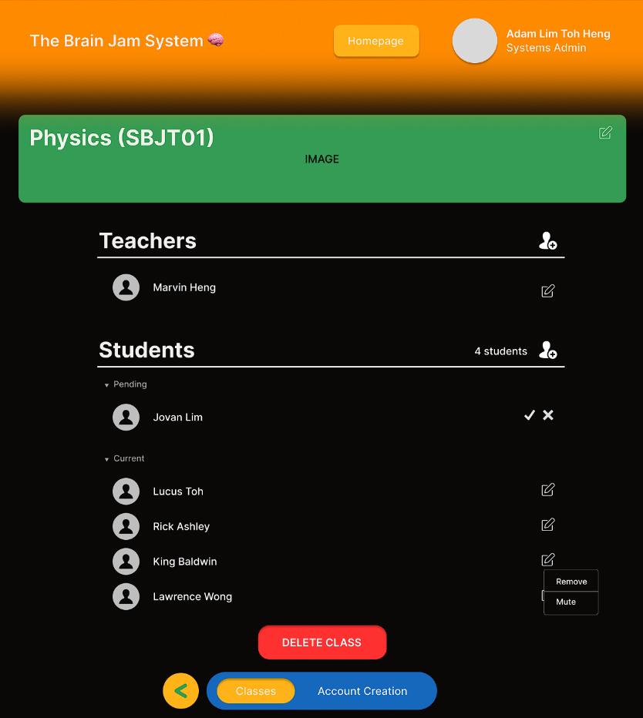

Admin Users on this page gets to view the class details. At the top, there is the class name and class banner. Following that, there is a Teachers section with the names of the teachers in charge of that class. Next is the Students section which states the total students currently in this class, with a Pending list of students that are waiting to be accepted, and a Current list of students already in that class. Below that is a DELETE CLASS button that deletes that class. Clicking on the pen icons beside the names will bring up a small menu with options to Remove or Mute that person, where Remove will remove that person from the class in the tuition centre’s database, and Mute will update that person’s chat permissions to mute. Clicking the pen icon at the class banner will allow the Admin User to edit the class name and banner. At the bottom beside the navigation bar is a back button that directs the user to **2.3.2 Admin Classes View** page.

**2.3.4 Deleting Class**

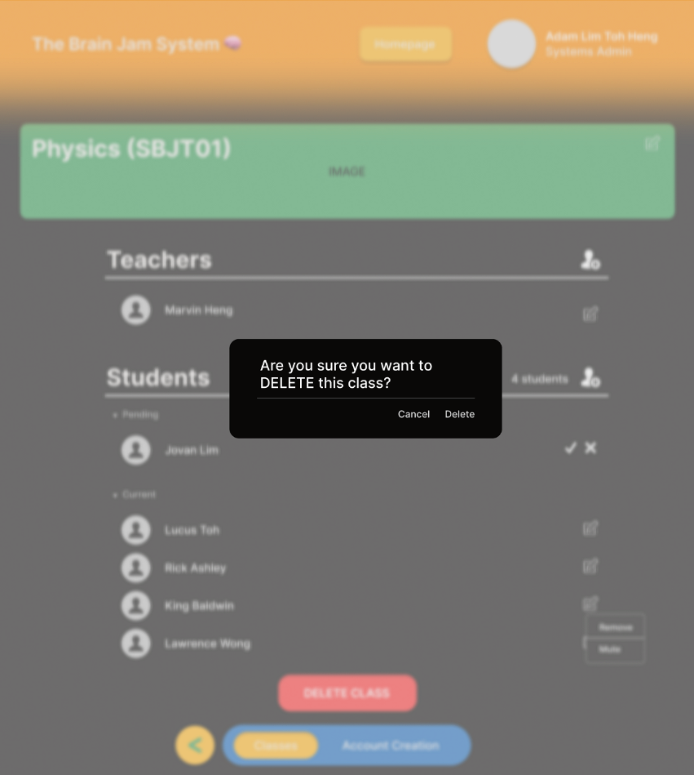

After clicking on the DELETE CLASS button at **2.3.3 Admin Class View** page, there will be this confirmation window pop-up that prompts the Admin User to confirm their actions again (to avoid mis-clicking and accidentally deleting a class). Upon pressing Delete, the class is deleted from the tuition centre’s database.

**2.3.5 Editing Class Info**

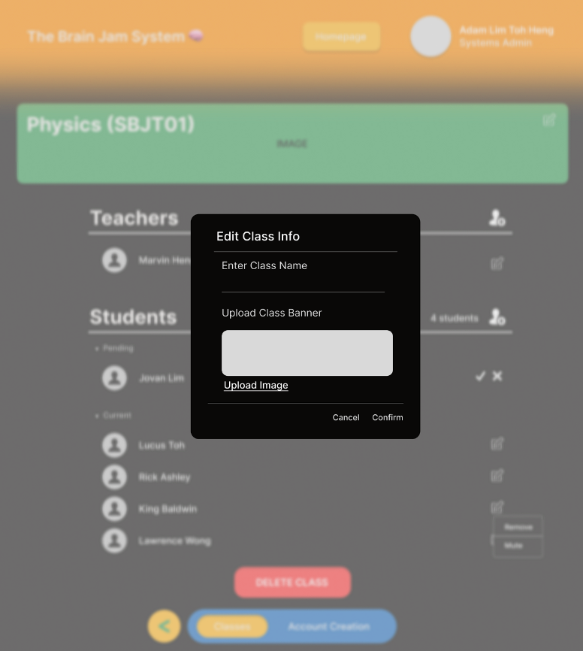

After clicking on the pen icon at the class banner, there will be this pop-up window that allows the Admin User to input a new class name and upload a class banner image. Upon pressing Confirm, the updated name and banner image will be posted to the tuition centre’s database.

**2.3.6 Adding Student to Class**

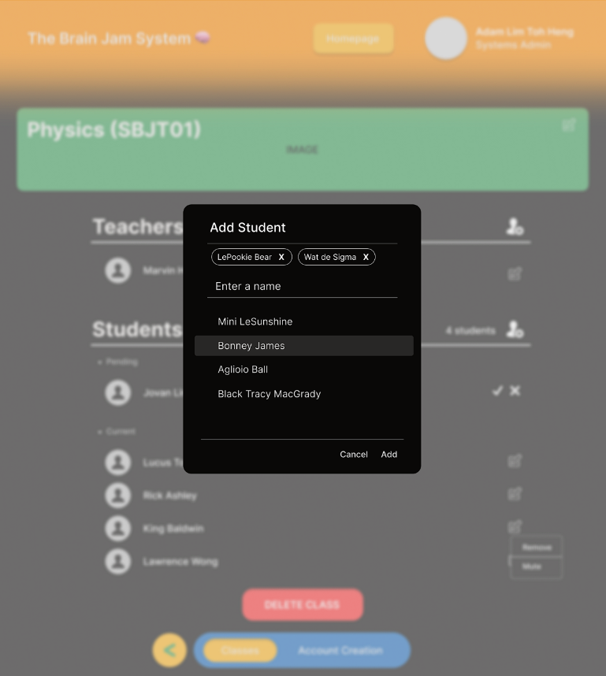

After clicking the add person icon beside the Students section header, there will be this pop-up window that allows the Admin User to input a student’s name to add them to the class. After choosing a student, it will be added to a list at the top of this pop-up, where pressing x would remove that student selection. Upon pressing Add, the student objects will be added to this class in the tuition centre’s database.

**2.3.7 Adding Teacher to Class**

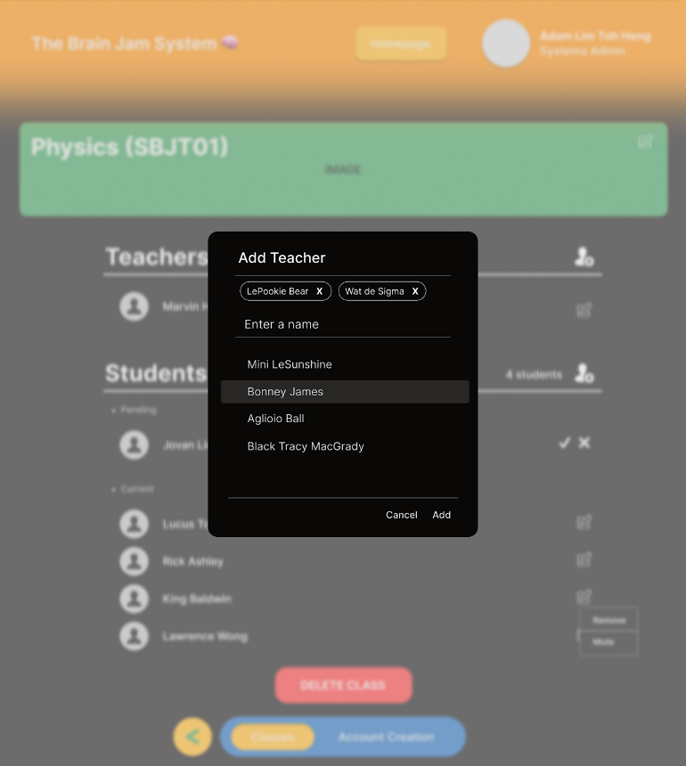

Similar to **2.3.6 Adding Student to Class**, after clicking the add person icon beside the Teachers section header, there will be this pop-up window that allows the Admin User to input a teacher’s name to add them to the class. After choosing a teacher, it will be added to a list at the top of this pop-up, where pressing x would remove that teacher selection. Upon pressing Add, the teacher objects will be added to this class in the tuition centre’s database.

**2.3.8 Creating a New Class**

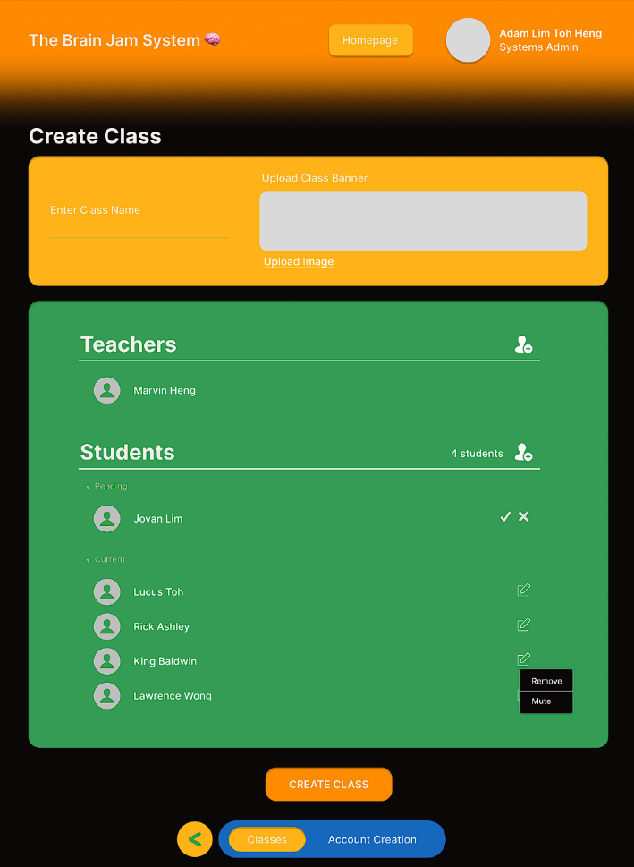

After clicking the + Create New Class button on **2.3.2 Admin Classes View** page, Admin User will be directed to this page. In the yellow box, the user can enter the new class name, along with uploading the new class banner image. In the green box, It is similar to **2.3.6 Adding Student to Class** and **2.3.7 Adding Teacher to Class**. Upon pressing the CREATE CLASS button, a new class object is formed with all the relevant class details and both teacher and student objects. This new class object will then be put in the tuition centre’s database.

**2.3.9 Creating a New Teacher Account**

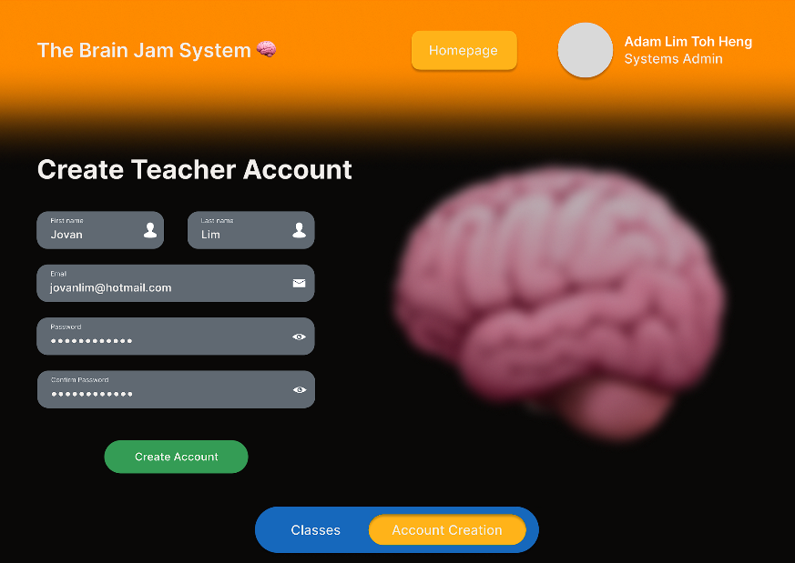

On this page, since teacher accounts can only be created by administrators, Admin Users can create new teacher accounts by inputting the teacher’s first and last name, along with their email address and desired password. Upon pressing the Create Account button, the new teacher object formed along with all of its relevant details is then put into the tuition centre’s database.

**2.4 Package 3 — User Sign Up (Student, Parent) (Jovan Lim, S10257399)**

**2.4.1 Create New Account Page**

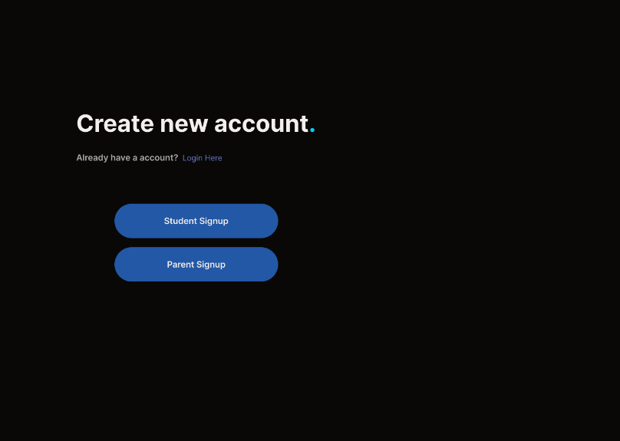

Users may create a new account as either a student of the tuition centre or as a parent of a student registered at the tuition centre on this signup page.

**2.4.2 Create New Student Account**

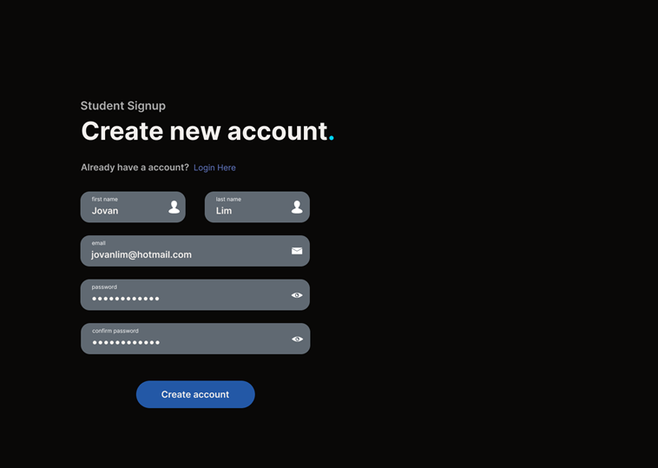

The student will be required to fill in these details in order to sign up as a student. They need to fill in details such as first name, last name, email address and password. Once they have filled in the details, they will be able to sign up as a student.

**2.4.3 Create New Parent Account**

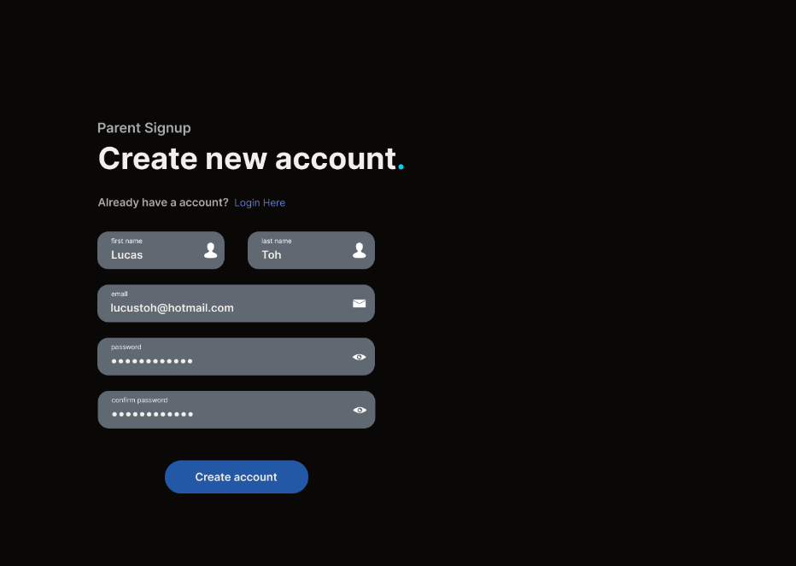

The parent will be required to fill in these details in order to sign up as a parent. They need to fill in details such as first name, last name, email address and password. Once they have filled in the details, they will be able to sign up as a parent.

**2.5 Package 4 — Teacher User (Jovan Lim, S10257399)**

**2.5.1 Teacher Classes View**

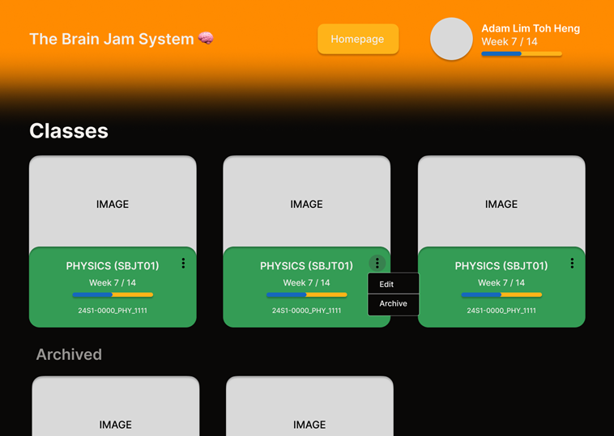

This page will show the classes of the teachers along with the option for the teacher to edit the details of the class or archive the class once the class suspended. The teacher can click on the class to go to the individual class page.

**2.5.2 Teacher Class View**

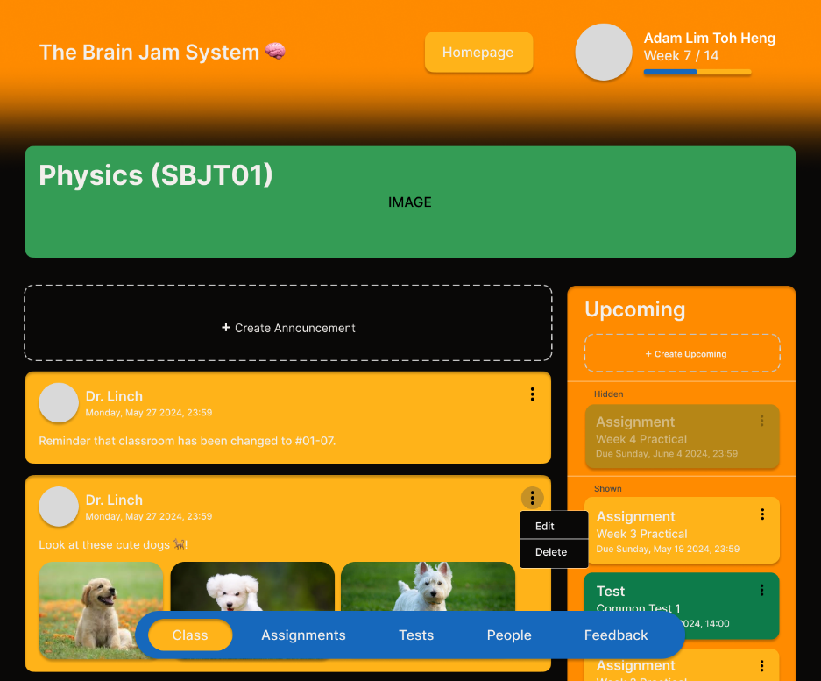

This page shows the current information on for the particular class. This page also allows the teacher to be able to create or preset announcements and upcoming events. The teacher can then change preset announcements and upcoming events from hidden view to shown view. In hidden view, the students and parents cannot see the announcements and upcoming events.

**2.5.3 Teacher Assignments View**

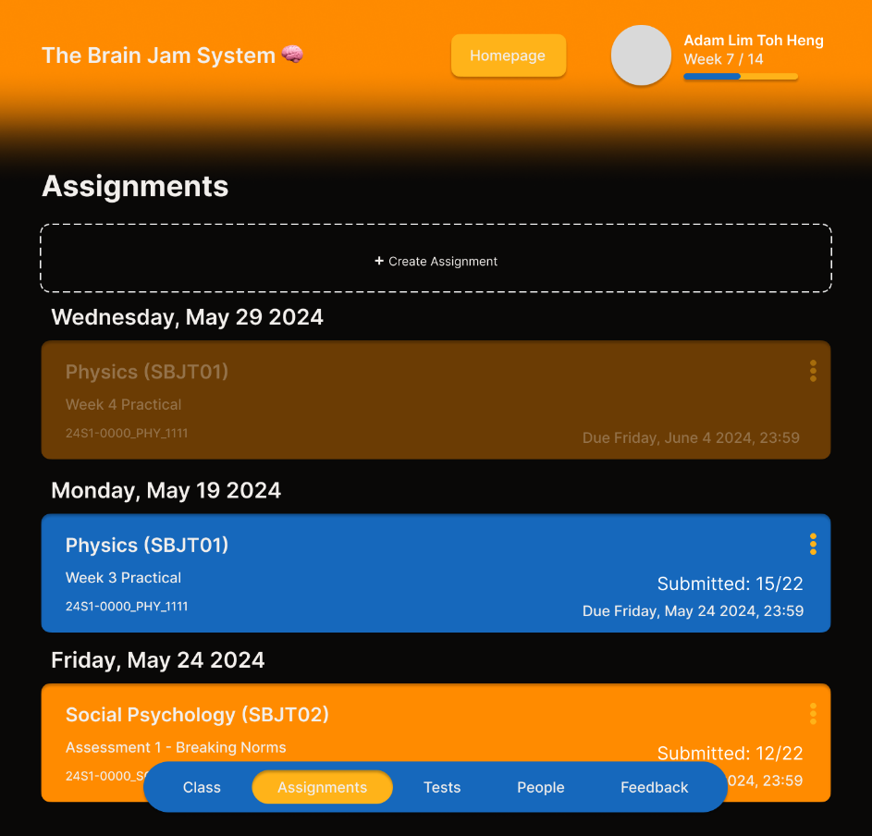

This page shows the current assignment on for the particular class. This page also allows the teacher to be able to create or preset assignment. The teacher can then change preset assignment from hidden view to shown view. In hidden view, the students and parents cannot see the assignment.

**2.5.4 Teacher Tests View**

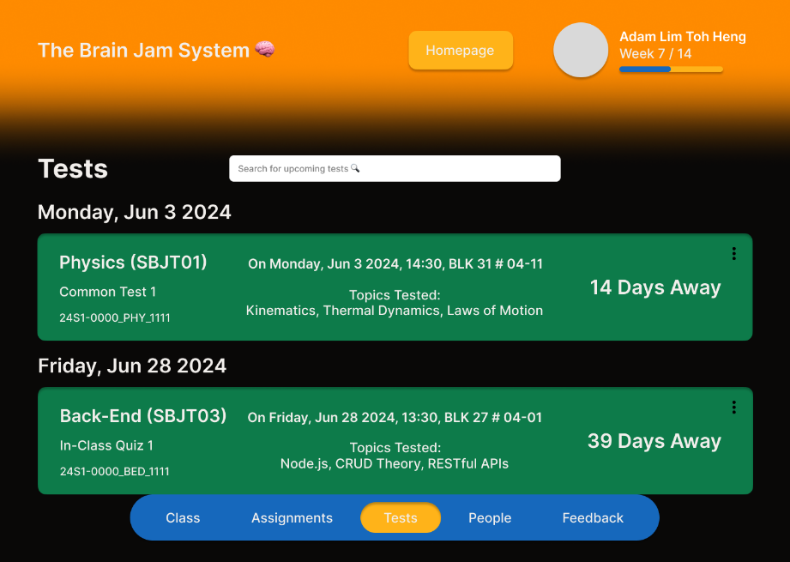

This page shows the test dates for the particular class. It also allows the teacher to search for a test using the search bar.

**2.5.5 Teacher People View**

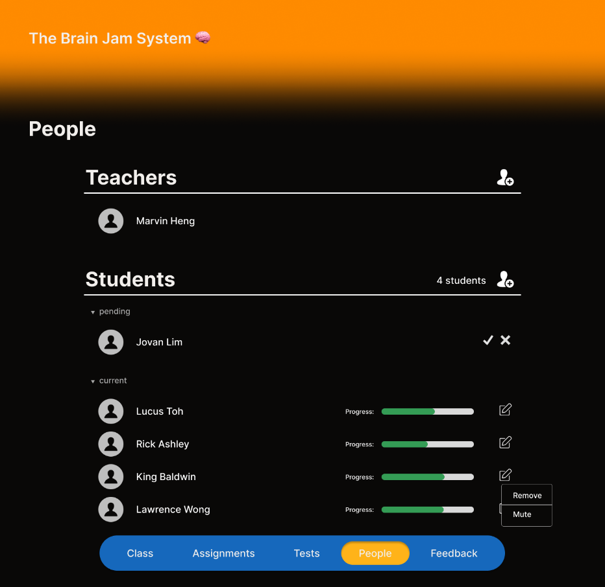

This page allows the teacher to view the students in his/her class as well as their progress bar. It also allows the teacher to be able to add teachers and also add, remove and mute students. The teacher can also accept or reject pending request from students to join the class. Clicking on the progress bar brings the teacher to the progress page of the student.

**2.5.6 Inviting Students**

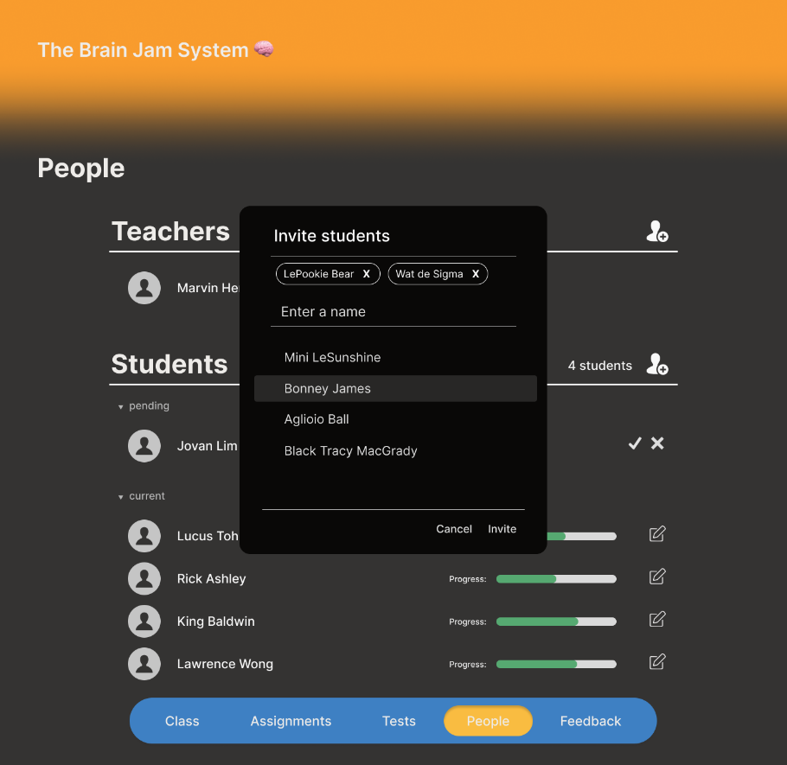

This shows how the previous page might look when the teacher is attempting to invite students to the class.

**2.5.7 Editing Student’s Progress**

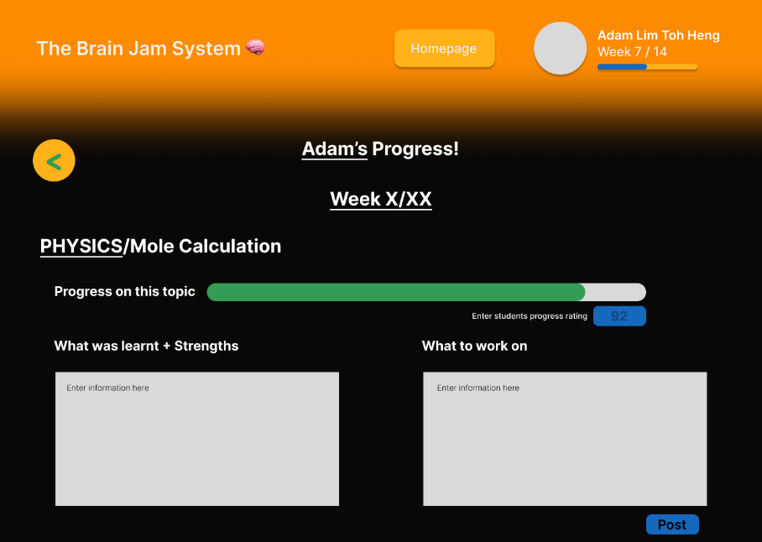

This page the progress of the student selected. This page allows the teacher to update the progress bar and comments when required.

**2.5.8 Parent Teacher Feedback View**

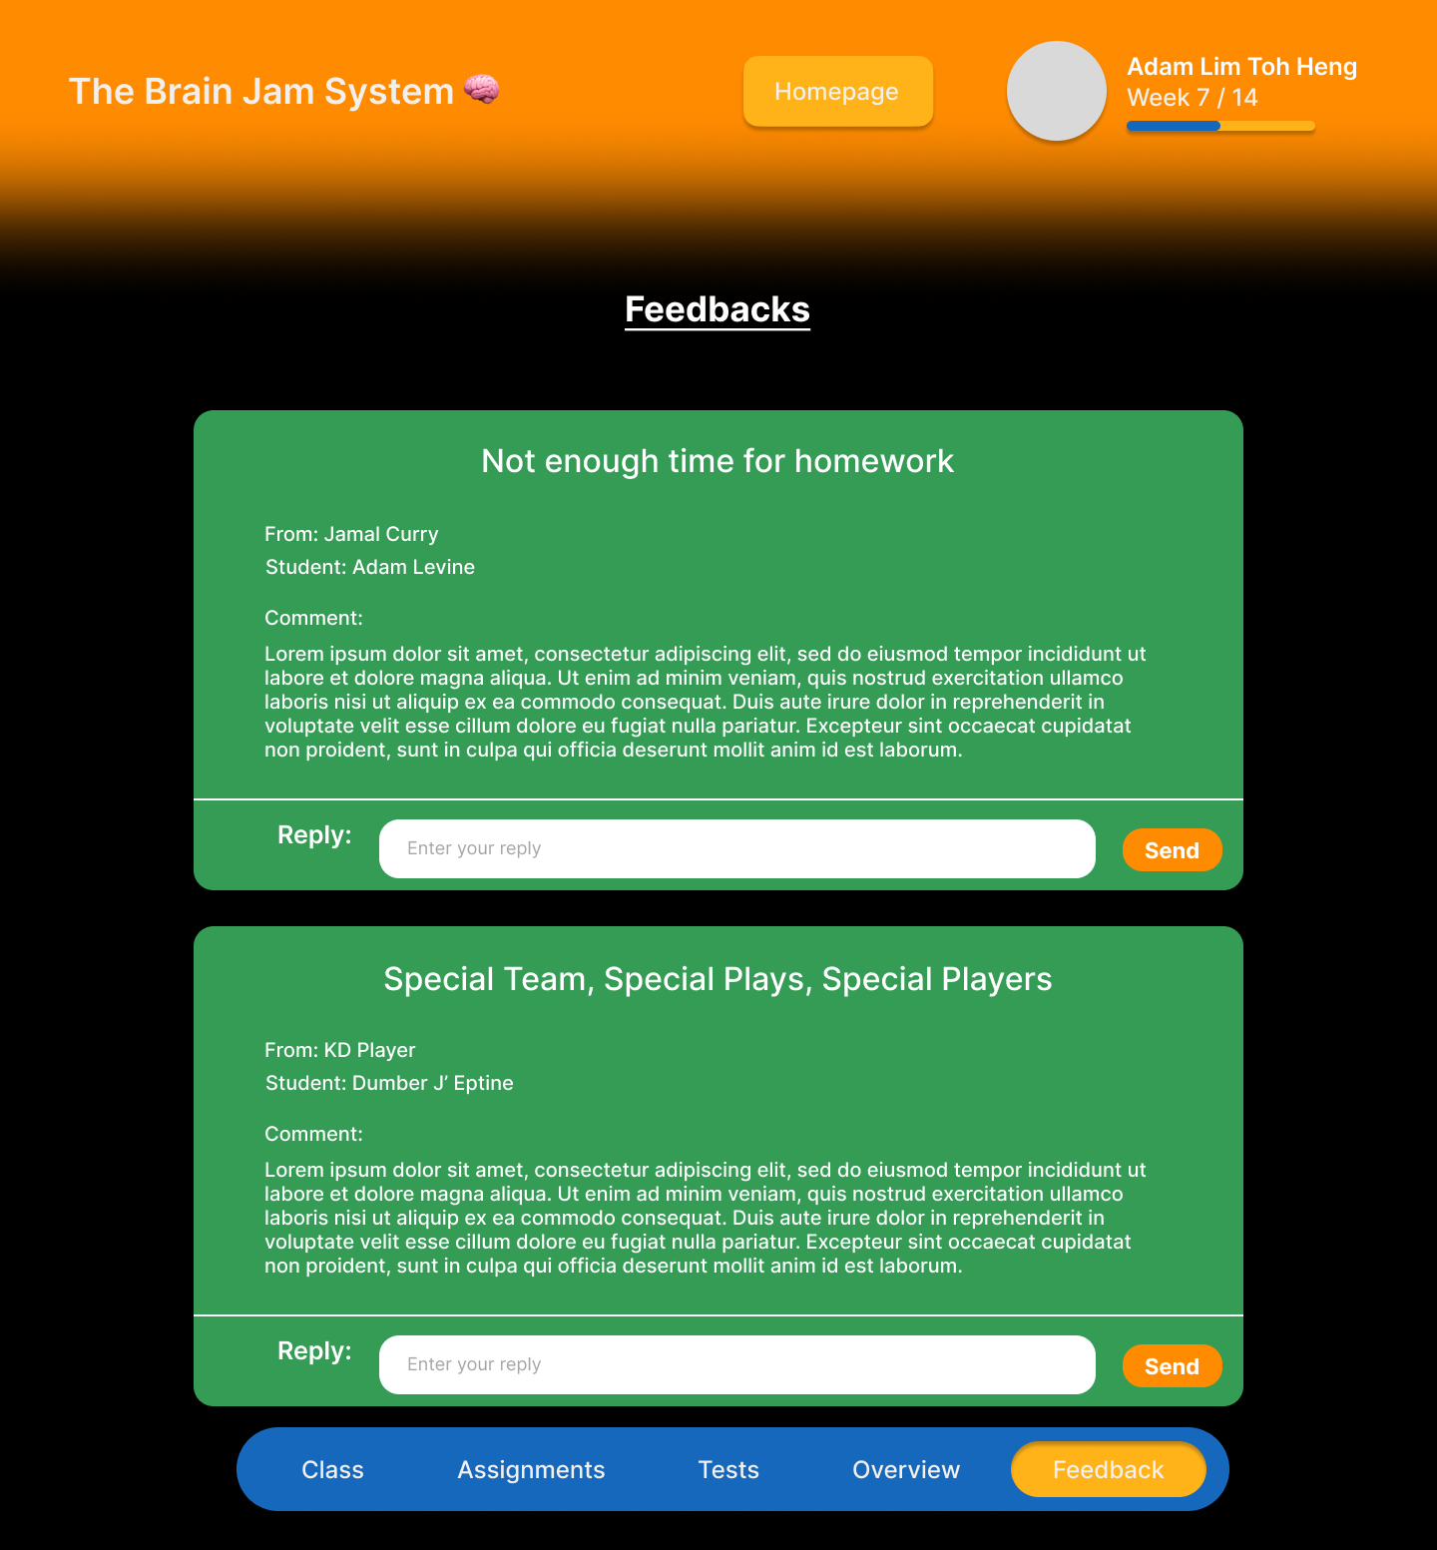

This page allows the teacher to view the feedbacks given by the parents of the students in the class. It also allows the teacher to reply to the feedback if necessary.

**2.6 Package 5 — Parent User (Lucas Toh, S10257164)**

**2.6.1 Parent Teacher Feedback Input**

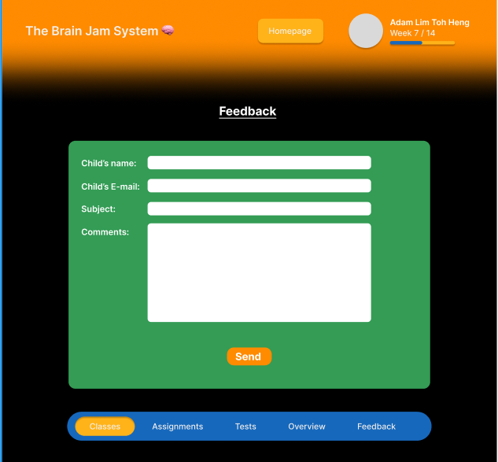

This page allows the Parent to submit a feedback form to the Admin about matters such as feedback on the teachers or curriculum. These feedbacks will be sent to a pool of feedbacks that can be seen by the Admin and the teachers.

**2.6.2 Payment for Child’s Tuition**

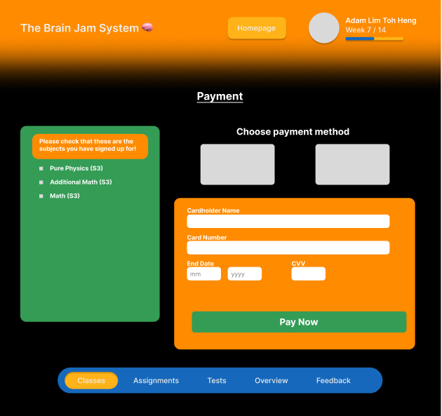

This page allows the Parent to pay for their child’s tuition fees online rather than paying it in person over the counter. They can choose their payment type via type of card and the rest of the form must be filled in by the parent before they pay. The parent must also check on the left to see if they are paying for the correct courses and subjects for the child.

**2.6.3 Learning Progress Overview**

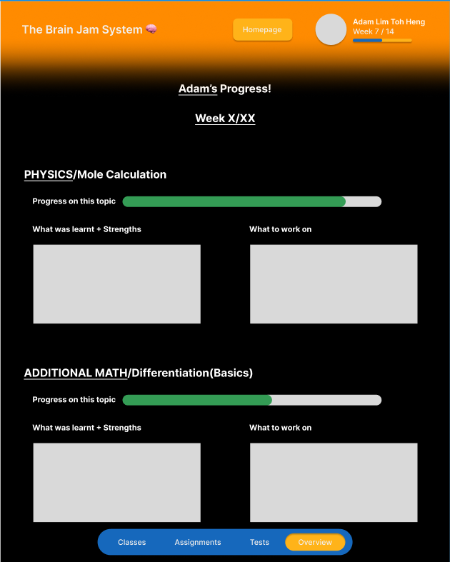

This page allows the Parent to view the child’s progress in class. There is the subject name followed by the topic name covered that week at the start of every subject review. The bar that shows “Progress on this topic” is submitted by the teacher where they see if the child is able to do the topic based on their assignments and in class participation. After that there is a space where the teacher submits what the child has learnt and what they did well at for that topic, and what they can work on like giving certain questions for them to work on before their next class. This page is the same as what is viewed by a Student User under the Overview tab in the navigation bar.

* + 1. **Parent Class View**

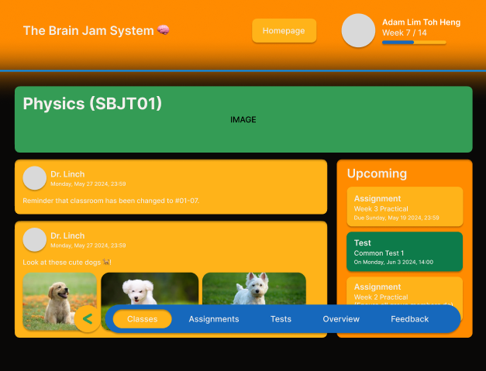

This page is the parent class page where the parent can see what classes their child is taking and certain details about them. There are announcements posted here as well as upcoming tests and assignments in this page so that the parents can stay up to date and know about their child’s learning.

**2.6.5 Class Syllabus View**

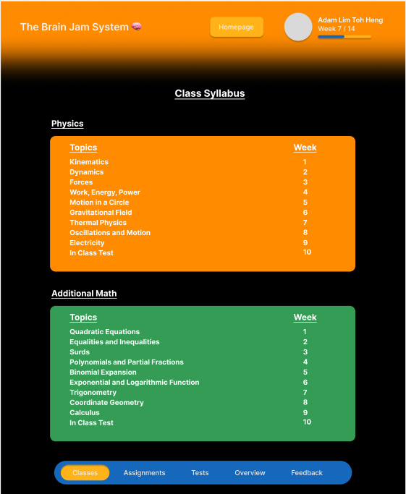

This page allows both students and parents to see their/their child’s syllabus according to what subjects they take. This page shows the subjects they take and the corresponding topics that is taught, together with the week that it will be taught so that the parents can also keep up with what their child is learning.

**2.7 Package 6 — User Login (Student, Parent, Teacher) (Lucas Toh, S10257164)**

**2.7.1 Student Login Page**

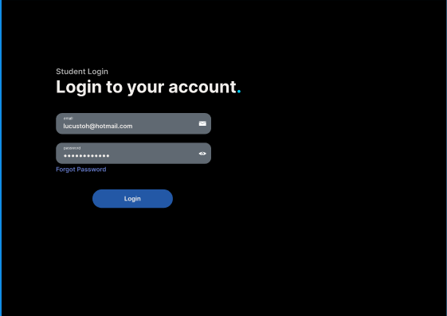

This page is for students to sign in to their account and to access their materials and announcements. They will have to enter their email and corresponding password to log in successfully.

**2.7.2 Parent Login Page**

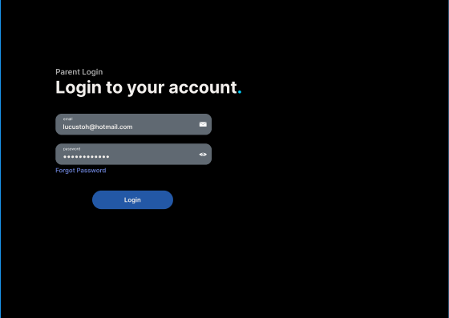

This page is for Parents to sign in to their account and to see their children’s materials, announcements, and their progress in class and tests. They will have to enter their email and corresponding password to log in successfully.

**2.7.3 Teacher Login Page**

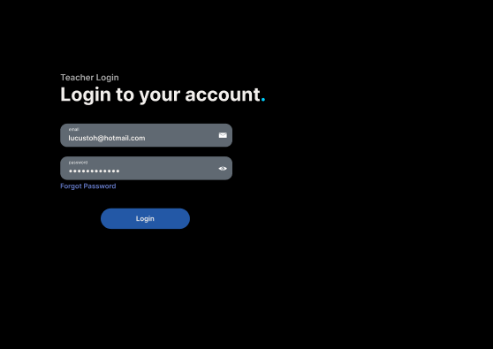

This page is for Teachers to sign in to their account to upload materials and input feedback for the students. They can also put up announcements for the students and parents to see. They will have to enter their email and corresponding password to log in successfully.

**CREDITS (3)**

**Document Formatting and Compilation** — By *Marvin Heng*

**Site Map** — By *Jovan Lim*

**Master Pages** — By *Marvin Heng*

**Packages 1 & 2** — By *Marvin Heng*

**Packages 3 & 4** — By *Jovan Lim*

**Packages 5 & 6** — By *Lucas Toh*